CIS 1250 PYTHON FINAL

For Ed Fong

# Turn in Requirements:

1. Name project FongFinal
2. Click Button and player gets 5 rolls.
3. Screenshots of running program to demonstrate different phases of game.

# Documentation Requirements:

1. Write the file name, your name, email address and purpose of the program at the top of your source code in a comment.

# FongFinal

# Programmer: Edward Fong

# Email: efong @cnm.edu

# Purpose: Dice game where player plays against computer. 1 game consist of 5 rolls.

# Winner is the one (either computer or player) with the highest score after once game ends

1. Add comments as appropriate. Be sure that your program output is neatly presented to the user.

# Problem:

Write a GUI based dice game that allows a player to click a button that uses a random generator to simulate the roll of a dice. Upon the launch of the game, a splash graphic image will be displayed on the screen. Once the Start button is pressed the image will go away and the roll button will become active. The player will have two dice displayed on the screen which can be either Unicode dice characters or an image of dice that changes based on the random numbers created by the random generator. Another set of dice will also be displayed on the screen representing the computers dice. During each play, a message label will display who won the round. Once the 5th roll has been made the roll button is disabled and a graphics message will pop up. There will be two graphics. One shows that the player won. The other graphic will say that the player lost the game and displays message also saying to play again.

Optional Feature: A sound will play at the end of the game corresponding to a win or loss. For example, a hooray sound will play when game was won. And an awe… sound will play when game was lost.

# Program:

1. The program will use the TKinter module for the GUI components, pygame for the sound option, and Pillow for the images.
2. The window sizes of the program will be 725 x 725.
3. Set up app to determine center of the screen and center the launch to the center of the screen.
4. Create labels and buttons for the game. You will need to create
   1. Two sets of dice. One for the player and one for the computer. A List of the 6 dice options will be created. A dictionary that corresponds to the 6 dice in the list to be used for the numbers of the dice will also be created.
   2. Game rule label that displays the rules of the game
   3. 2 labels, one for the player and one for the user that displays what number value each has rolled. At the beginning of the game, display something like, “No rolls yet”.
   4. 2 labels that go above each set of dice that say something like, “Your dice” and “Computer’s Dice”
   5. A label that has a larger font size that displays if the player won or lost.
   6. A label that displays the number of rolls each time the player presses the roll the dice button. The number resets back to 0 when the start/replay button is pressed.

The labels and dice need to show and hide accordingly to have a congruent game play. For example, when the last play is played and the Game over or you won graphic displays, the dice, depending on the position of the graphic needs to hide.

1. You will create to functions. The roll dice function that rolls the dice and the start/reset function that resets everything and starts the game.
2. Optional: Create a custom dice icon for the game that replaces the default leaf.
3. Optional: Make program to be object oriented instead of procedural.

Opening Game will look something like this. Pressing Start/Replay will look like this.

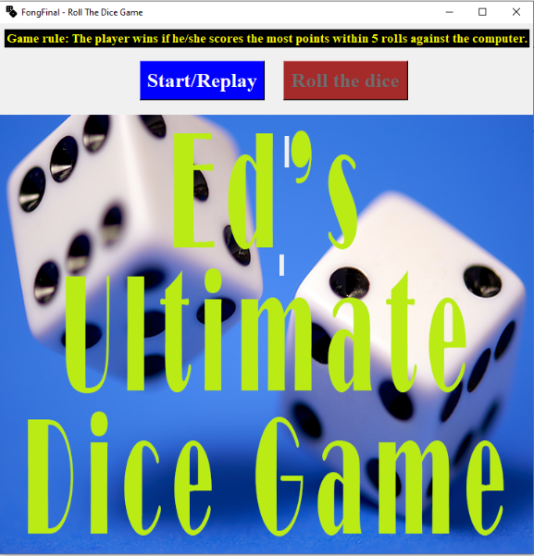 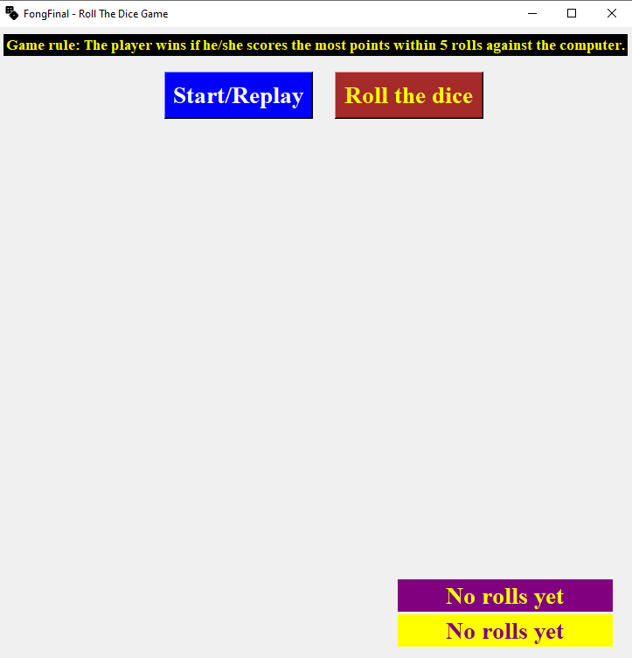

**Pressing Roll the Dice After Lost Round: Winning Round looks like this:**

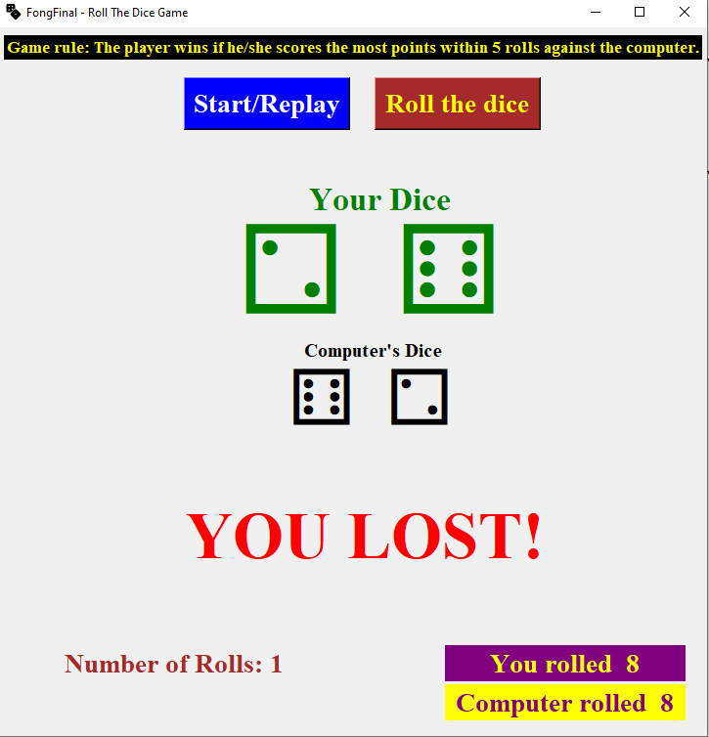 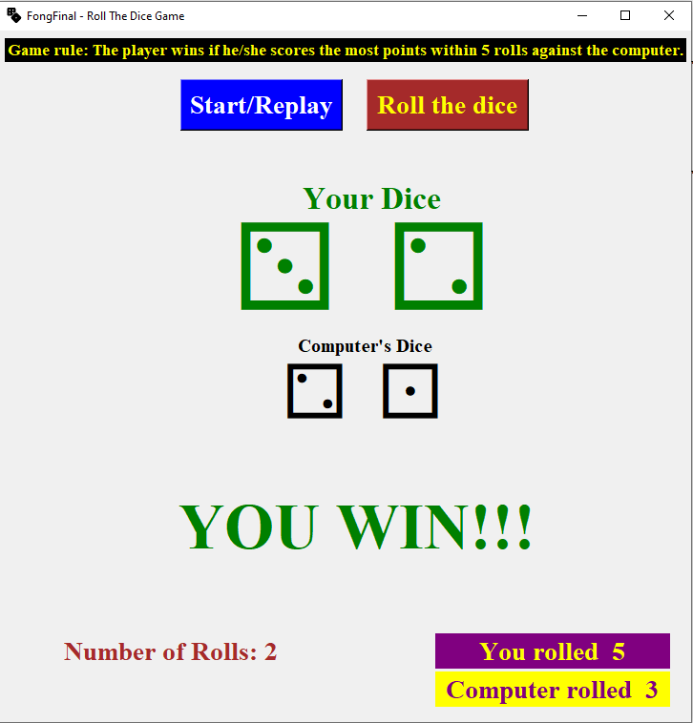

**Loosing the game will look like this: Winning Game will look like this:**

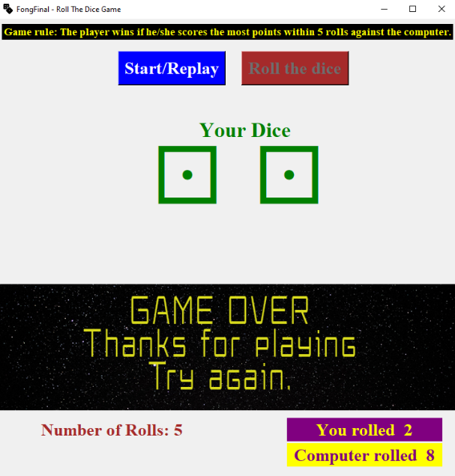 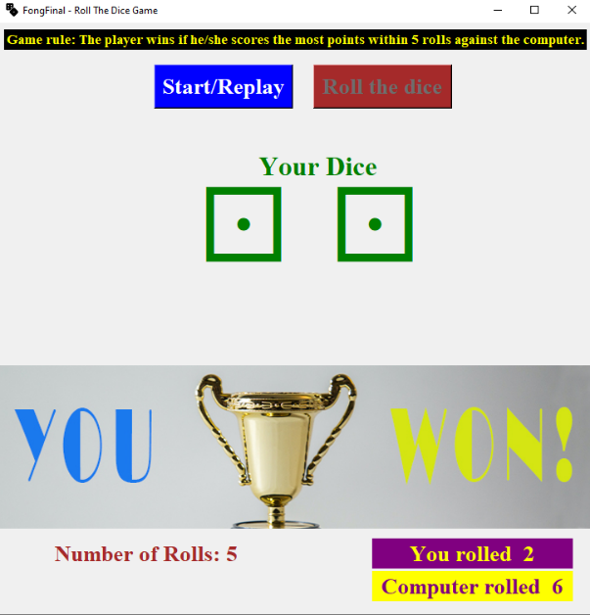

# Hints:

You can use Canva to make custom graphics or use photoshop. Unsplash has royalty free graphics that you can use to create graphics.

Splash Image:

Photo by [Edge2Edge Media](https://unsplash.com/@edge2edgemedia?utm_source=unsplash&utm_medium=referral&utm_content=creditCopyText) on [Unsplash](https://unsplash.com/s/photos/dice?utm_source=unsplash&utm_medium=referral&utm_content=creditCopyText)

## Notes for program:

Command to make exe file using pyinstaller for program: pyinstaller --onefile --noconsole --icon=dice.ico

Omit --onefile if you want multiple files in one folder that includes the exe file in it. Makes program run faster.

FongFinal.py <https://www.pyinstaller.org/>

### Dependencies:

pygame, pillow

Need to make sure pip is installed

curl [https://bootstrap.pypa.io/get-pip.py -o get-pip.py](https://bootstrap.pypa.io/get-pip.py%20-o%20get-pip.py)

python3 get-pip.py

To create an executable program on Windows:

Create batch file named pyinstaller.bat

curl [https://bootstrap.pypa.io/get-pip.py -o get-pip.py](https://bootstrap.pypa.io/get-pip.py%20-o%20get-pip.py)

python3 get-pip.py

pip install pygame

pip install pillow

pip install pyinstaller

pyinstaller --windowed --icon=dice.ico FongFinalRevised.py

copy splash.png .\dist\FongFinalRevised\

copy game-over2.jpg .\dist\FongFinalRevised\

copy youwon.jpg .\dist\FongFinalRevised\

copy applause.wav .\dist\FongFinalRevised\

copy ooh.mp3 .\dist\FongFinalRevised\

or

If file pyinstaller.txt is in the folder, change the filetype to .bat ex. pyinstaller.txt to pyinstaller.bat

You can either click the batch file or open a command line and open the batch file from the command line. It’s better to do it in command line as you can see if there were any errors during execution.

If all goes well, there should be a dist folder. Open this folder and find the FongFinalRevised.exe file. Click on the file and the program will open.

The entire repository is located at <https://github.com/efong505/Eds-Dice-Game>

The README.md file is at: <https://github.com/efong505/Eds-Dice-Game/blob/main/README.md>

Enjoy!